Minimum Viable Product

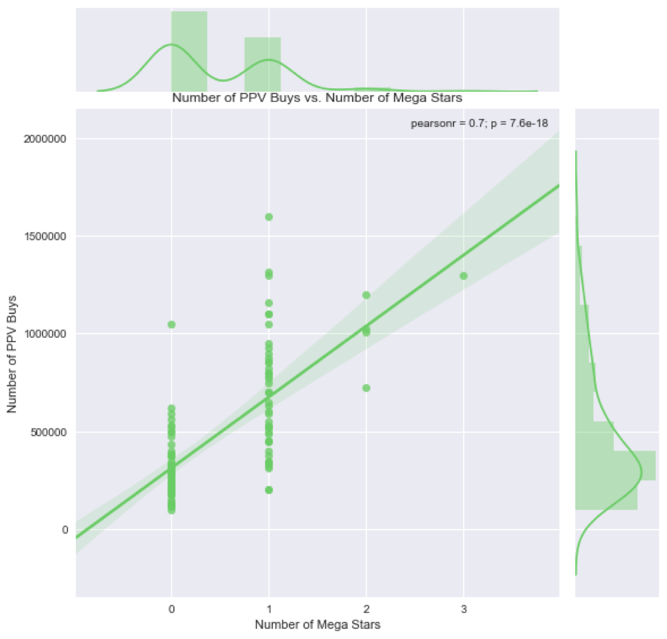

The objective of my project is to predict number of UFC Pay-Per-View Buys. I noticed the high correlation ( or tight fit) (denoted by the Pearson coefficient of 70%) between the number of mega UFC celebrities and PPV Buys so I decided to create a joint plot. I can reject the null hypothesis that the linear regression is due to chance b/c of the very small p value.

We can clearly see that as you start increasing the number of mega stars, PPV buys increase as well where even having one mega star brings it above its average number of buys. For every one mega star starring in a UFC fight, PPV buys increases by 201,900. The mega stars can account for the positive skew of the PPV buy graph.